17 March 2023

Dear Parent/Guardian
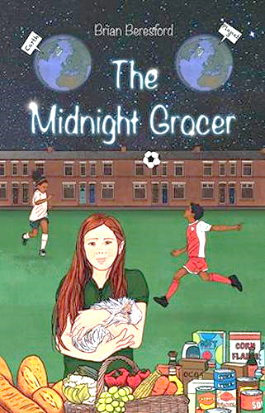
I am a former teacher and headteacher in North Yorkshire and Lancashire Primary Schools. I am also an author of books for children and adults.

Today I visited school and presented an ‘Author Visit’ with reference to my new book, ‘The Midnight Grocer’, which is for children aged 8 to 12.

The session was all about the importance of stories in our lives, how stories can be spoken, written or sung, our favourite stories and books and how I wrote ‘The Midnight Grocer’. I read excerpts from the book and involved the children in practical activities. The book includes a link to a YouTube video of my song, ‘Midnight Grocer, Who are You?’ which I taught to the children today. Perhaps they would like to sing it to you? – you can find it on YouTube by Googling the song title.

I gave my time to the school free of charge, so they won’t be asking you to contribute towards any fee! However, please talk to your child about ‘The Midnight Grocer’ and, if you think it has inspired them, consider buying a signed copy for them. If you would like one, please return the attached slip to the school office by No later than Thursday next, 23 March and pay £7.99 to my Barclays account at Sort Code 20-27-05, Account number 60869708, Account name Brian Beresford. I will then return to school with your book a few days later.

Thank you!

Yours sincerely

Brian Beresford, Author
Skipton

I wish to order _____ signed copy/copies of ‘The Midnight Grocer’ by Brian Beresford and will pay £7.99 to the bank account noted in the letter.

Signed__________________________________________

Parent/guardian of ___________________________________ Class______________

