Sunday 17th December

4.00 pm

Sawley Church

come and share the excitement!









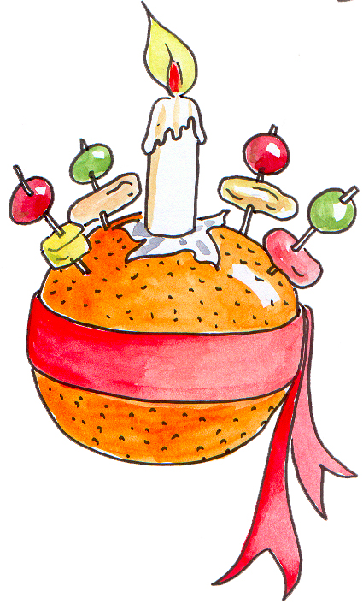

Come and

celebrate

Christingle