# How to Set up the Challenge

* Collect at least five pairs of socks that are different in pattern

and colour.

* Place the single socks in a muddled pile or in a basket.
* Children can match the socks and put them in pairs.
* Repeat the activity but remove one sock. Talk about how there is an odd sock that does not have a partner.

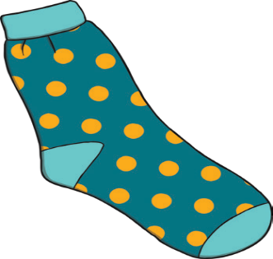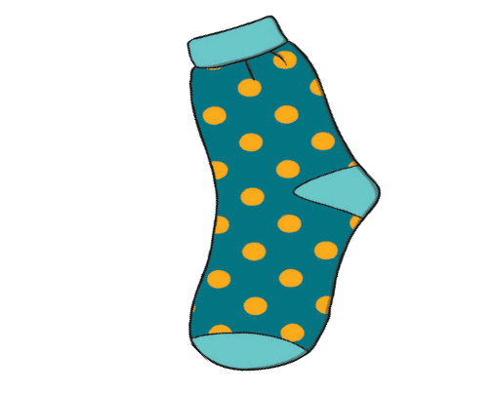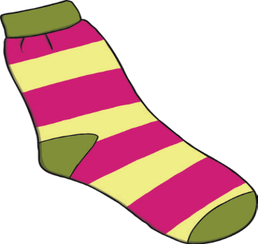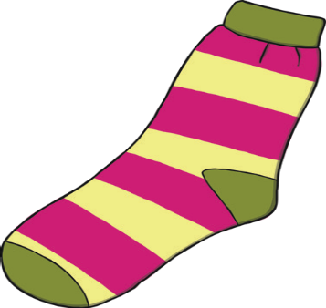

**Pairs of Socks**

* Can you put the socks in pairs?
* How do you know these socks are a pair?
* How are the pairs of socks different?
* Can you count how many pairs of socks there are?
* Are there any odd socks?