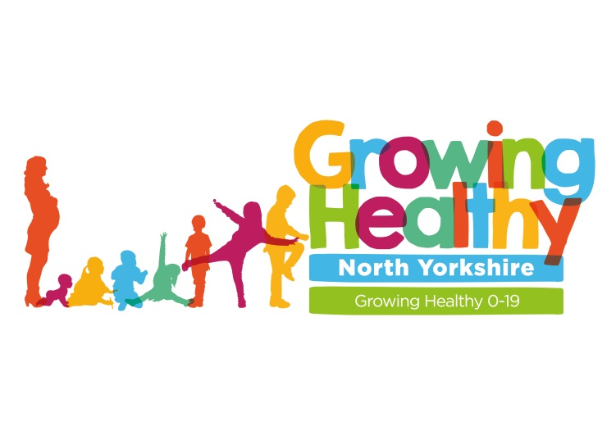

Influenza Vaccination
Autumn / Winter 2021

Catch up clinics for school aged children (up to and including Year 11) who have missed the Influenza Vaccination in the Harrogate/ Knaresborough/ Ripon locality.
DROP IN SESSIONS FOR THE NASAL FLU SPRAY
(Please note if you require the IM injection for flu this will need to be a booked appointment- please call 01423 553115 to organise this)
Venue: Knaresborough Community Centre
Stockwell Avenue, Knaresborough, HG5 0LG
(Please note this is not the Children’s Centre in Knaresborough)

Dates: Tuesday 23rd November; Tuesday 7th December 2021.
Time: 15.00- 16.30
Type of session: Drop in for nasal spray (booked appointment if you require the IM injection)
Venue: Jennyfields Styan Community Centre
Grantley Drive, Harrogate HG3 2XU
(Please note this is not Jennyfields Medical Centre which is further down the road. The Community Centre is opposite the Co-op)

Dates: Tuesday 30th November; Tuesday 14th December 2021.
Time: 15:45-17:15

Type of session: Drop in for nasal spray (booked appointment if you require the IM injection)
If you miss or cannot attend one of the above clinics, or should you wish to discuss any aspect of the Influenza vaccination programme please contact the Childhood Immunisation Team on the following:
hdft.childhood.immunisations@nhs.net or ring via 01423 553115
Kind Regards
The Childhood Immunisation Team
Harrogate and District NHS Foundation Trust

