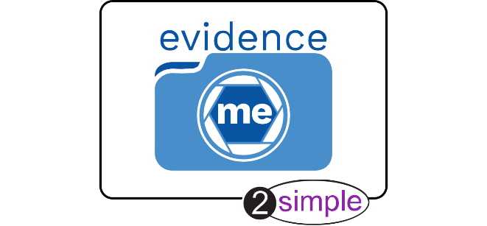
Dear Parent/Carer,

At Fountains Primary School we will be using Evidence Me, a system which will allows us to share what your child is doing in school.
The ‘Parent Share’ feature in Evidence Me enables you to view your child’s observations (complete with photos and/or videos) via the app or web site, showing you what your child has been learning and the new skills they are developing.
We hope you will enjoy sharing in their experiences!
You can send us your comments and feedback by simply adding them to the observations via the app or web site. This will help staff to support your child even more effectively in the classroom.
You can also take an active role in contributing to your child’s observation portfolio by uploading your own observations, simply add these to the app or web site.

We would be grateful if you could complete the attached consent form, returning this to school where we will set up your account. Following this you will receive an email from donotreply@evidence.me asking you to confirm that you would like to participate. Make sure you check your spam/junk inbox as sometimes emails can get lost in there.
Participation is optional, but we really recommend getting involved. If you have any questions or need any additional information, please contact Miss Wray directly.
We look forward to supporting you and your child and are always striving to provide the highest standard of education possible.
Please visit http://help.evidence.me/evidence-me-help-for-parents/ for further information and guidance.

Kind regards

Georgina Wray

“Teachers and parents tend to be so busy that often you had to wait until parents evening to really find out what your child had been doing in school. But with Parent Share I get regular updates, complete with photos and comments from the teacher straight into my inbox. I think it’s wonderful and it has really helped me support my child’s learning at home. My husband and I love reading through the reports together in the evenings. I would really recommend it to other parents.”
Julie Greenwood, Parent, Camden
Evidence Me and Parent Share are provided by 2Simple Software.
You can find out more about 2Simple by visiting www.2simple.com
Child’s Name: …………………………………………………………………………

As a parent I agree ….

- to allow photographs which include my child to be used in observations for other children (these will be stored on Evidence Me and in each child’s Learning Journal Folder as a hard copy)

- NOT to publish any of my child’s observations, photographs or videos on any social networking media site

(this means that the information cannot be shared with others, or published in any way, without the explicit consent of the parents or carers of those children who may be included. For example, any such photographs cannot be posted on a social networking site or displayed in a public place)

- to keep my log in details secure and will not share these with others

I give permission for the following people to be linked to my child’s online Learning journey:

Name: ……………………………………………………………………………………………..
Relationship to child: ……………………………………………………………………………………………..
Lives with child: YES / NO
Email Address (please write clearly):
………………………………………………………………………………………………………………………………….

Name: ……………………………………………………………………………………………..
Relationship to child: ……………………………………………………………………………………………..
Lives with child: YES / NO
Email Address (please write clearly):
………………………………………………………………………………………………………………………………….

Name: ……………………………………………………………………………………………..
Relationship to child: ……………………………………………………………………………………………..
Lives with child: YES / NO
Email Address (please write clearly):
………………………………………………………………………………………………………………………………….

Please note it is your responsibility to ensure that other family members understand the conditions above and do not misuse the photographs or other information placed on EvidenceMe, in signing this form you are accepting this responsibility. You can withdraw your consent in writing or request to see photographs at any time. This form is valid for the duration of your child’s time at school, it is your responsibility to let us know if you want to withdraw or change your consent at any time.

If you do not have access to email and would like to be able to view my child’s Learning Journey at agreed times in school please tick here ………..

Print Name: ………………………………………………………………………….

Sign: ……………………………………………………………………………………..

Relationship to child: ……………………………………………………………

Date: ……………………………………………………………………………………

