Autumn 2
Launch Day
Wednesday 3rd November

Our Big Question this half term is….

What do we
value the most?

All the children are focusing on Science this half term so to help us launch our learning journey we have invited Wild Science to join us for the day.
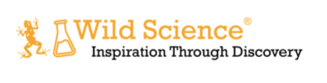

Wild Science is the leading provider of animal handling sessions and science experiences across the UK (and now the world, via Zoom). We are passionate about animals and science and use that enthusiasm to engage and inspire children and adults of all ages.

The children will be involved in a workshop linked to what they will be learning and will have the opportunity to handle and learn about a range of animals and their habitats.
We are asking for a voluntary contribution of £5 towards the cost of the workshop which will take place in school. We are using the online Parent Pay tool to handle payments. You will receive an e-mail inviting you to pay through the secure online system.

Please complete the consent slip below and also provide any details of allergies to animals please.

I consent for (name of child) _____________________________ to take part in the animal workshop.

Please provide details below of any allergies we need to be aware of:
______________________________________________________________________________________________________________________________________________________________________________________________________________________________________________________________________________________________________________________________________________________________________________________________________

Signed
Date

