Narwhal Whale
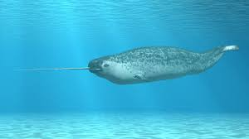
A narwhal whale lives in the Arctic.

They can live up to 50 years.

Some narwhal whales have a long spiral tooth that can grow to 3 meters long. It can also bend.
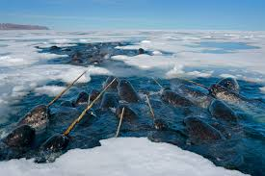
They live in pods of about 15 to 20.

Narwhals dive deep in the ocean then they crack the sea ice to pop up for air.

Find out more about the narwhal with this video: https://kids.nationalgeographic.com/animals/mammals/narwhal/
Walrus
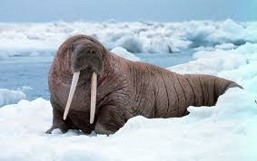
Walruses live in the Arctic and Subarctic areas.

They drag their back along while walking, the walrus can walk on their hind fins.

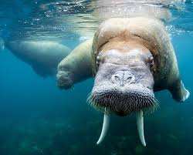
Walruses have tusks that help them climb out of the water and break the ice for them to breath. Walruses also fight, using their tusks, with other males.
They have a layer of fat called blubber under their skin to keep them warm.

Walruses live in very large herds.

Find out more about the walrus with this video:
https://kids.nationalgeographic.com/animals/mammals/walrus/

Emperor Penguin
Emperor penguins live in Antarctica. They are the largest penguins in the world.
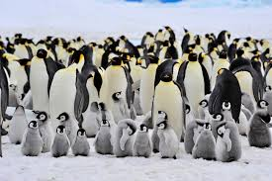
To keep warm, they have large stores of body fat and several layers of feathers. They also huddle close together in large groups to stay warm.

Emperor penguins lay eggs in the summer and the male makes sure the egg is safe and warm. The female leaves to find food.
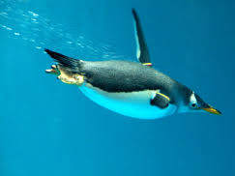
Emperor penguins are excellent swimmers and can dive very deep. They can stay under water for 22 minutes.

Find out more about the emperor penguin begin with this video: https://kids.nationalgeographic.com/animals/birds/emperor-penguin/

Polar bears
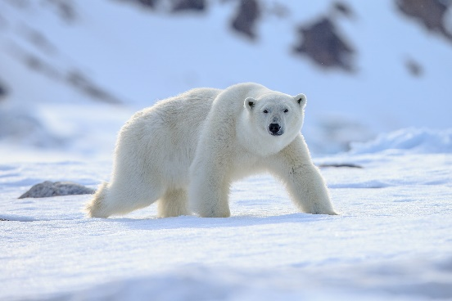
Polar bears live along the shore and on sea ice in the Arctic.

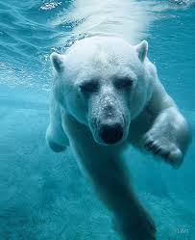
Polar bears have black skin and although their fur looks white, it is see through. Polar bears have a great sense of smell.

They use the Arctic sea ice to hunt seals.

They have a layer of blubber under their skin to keep warm.
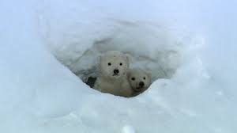
Young polar bears are called cubs. They are born in the winter while their mothers hibernate in a den.

Find out more about the polar bear begin with this video:
https://kids.nationalgeographic.com/animals/mammals/polar-bear/

