How to use email on purple mash…
On the home page press tools
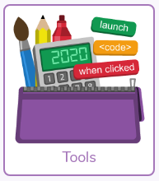
Then find the 2email app, which is found in the “communicating and sharing “ section .
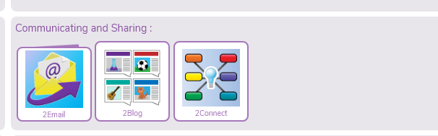
When you go into 2email you will find 2email app and the email activities. You should open the app :
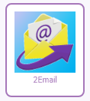

You can compose an email here and send it to me or other teachers and pupils. When you receive an email in reply, you will see an alert at the top of your home page.
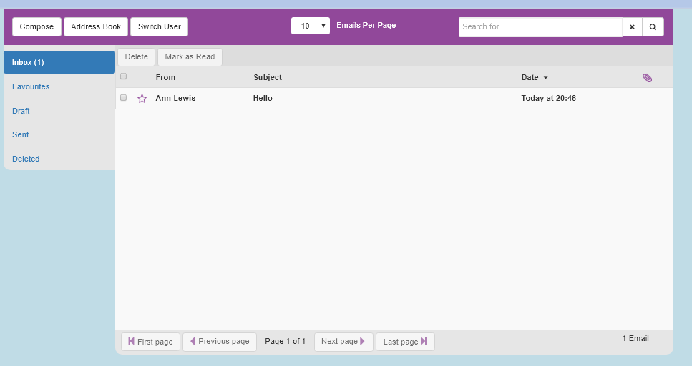
As far as we are aware you can only attach work and images that are created within purple mash to purple mash2 emails. This is to ensure the safety and protection of all children.

If you wish to send photographs or files of work completed away from the computer or Purple Mash, and then please continue to email them to the school admin and they will be forwarded to us.
As ever this is a steep learning curve for us all, so please do shout and we will do our best to help!

