Dear Parents

We have set up a seating plan for Motley’s Bus Service. We hope that by doing this, it will ensure that the journey to and from school is a pleasant experience for all our children. School staff will put the children in the correct seat after school, and we would ask that parents and carers put their children in these seats on a morning, starting from Tuesday 9th April.
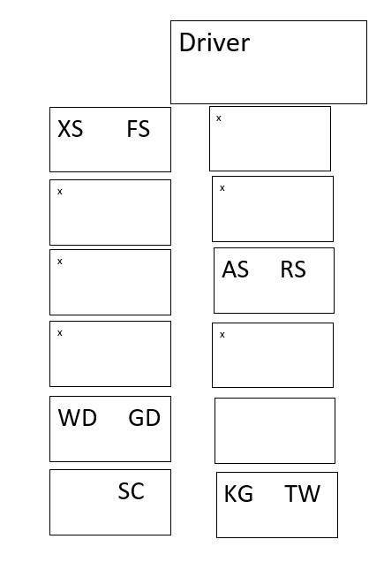
Should your child require assistance with their seatbelt, please could we ask that you or the adult putting them on the bus helps them with this, not the other children onboard. School staff will ensure that all children are seat belted correctly before the bus departs school.

If you have any questions, please get in touch.

Mrs Acheson

