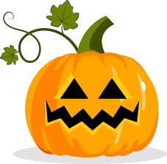
HALLOWEEN LUNCH
Thursday 26th October
Spooky Sandwitch
Ham
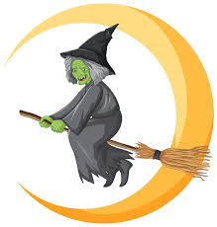
Wicked Witches’ Fingers
(Hot dogs with Tomato Ketchup)

Petrifying Potato Wedges
Horrifying Halloween Cookie
