Toys information sheet
My toy | What is it made from? | An interesting fact
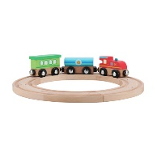 | Wood  Plastic  Metal | The pieces join together with magnets

