Week 1 – Week beginning 06.04.20

PE ideas:

-Daily challenges:
Click on the below link to access the daily challenges produced by the Harrogate School Sports Partnership. You don’t need anything that you won’t have at home, and they’re lots of fun! There’s more information on the news page of the school website.
https://www.harrogatessp.com/home-personal-best-challenge/

-RealPE at home:
See the news page of our school website for more information about these fun and exciting activities that you can do at home. This is the website:
https://home.jasmineactive.com/login

Websites:
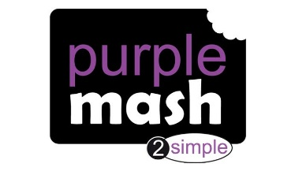
Remember, you can still access all the websites you’ve been using over the last couple of weeks:

Purple Mash https://www.purplemash.com/sch/fountains-hg4

Sumdog https://www.sumdog.com/user/sign_in

TT rock starts https://play.ttrockstars.com/auth/school

Accelerated reader https://ukhosted79.renlearn.co.uk/6706937/
Reading Plus https://student.readingplus.com/seereader/api/sec/login

Easter activities:

I spy colouring Easter colouring:
https://www.papertraildesign.com/i-spy-easter-activity/

Easter cross mosaics:
https://www.pinterest.co.uk/pin/36943659422155347/
A variety of Easter crafts:
https://www.easypeasyandfun.com/easter-crafts-for-kids/

https://www.thebestideasforkids.com/easter-crafts-for-kids/
https://meaningfulmama.com/category/kids

Other fun ideas:
https://www.buzzfeed.com/mallorymcinnis/we-oughta-give-it-a-try
Educational activities for parents / kids – science links
https://www.jumpstart.com/parents/activities/

Scroll down for Easter bingo!

Easter activity bingo!
Do some origami. You could decorate your own paper too! | Draw or paint a butterfly with exotic colours. | Make your own sock puppet. | 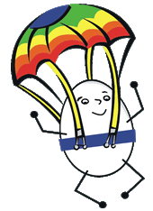  Design and make a parachute to protect a boiled egg. | 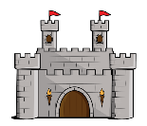  Make a castle using an empty box. | Make some cornflake or rice crispy cakes.
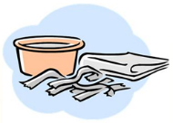  Make a papier-mâché sculpture. | 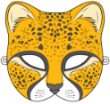  Design a mask for yourself – it could be an animal, warrior or something else! | 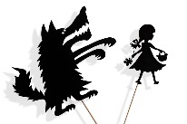  Make some shadow puppets and put on a show. | Use spaghetti or toothpicks and marshmallows to build 3D shapes. | Make an Easter egg hunt using real or paper eggs. | Go for a walk and take some photographs.
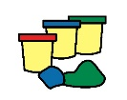  Make some playdough or clay and build an animal | 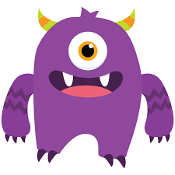  Make your own monster bookmark | Make a rocket using recycled card or plastics | 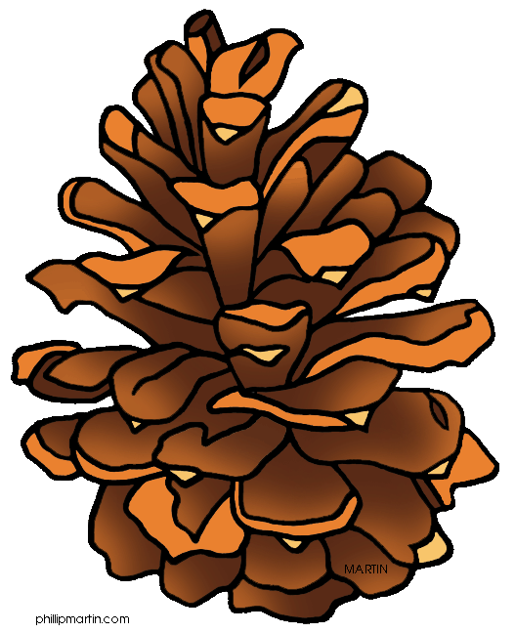  Collect some nature things make an Andy Goldsworthy picture or collage. | How many times can you throw and catch a ball with a family member without stopping? | Video call a family member.
Make a den in your house or garden using fabric, cushions etc. | Read a joke or fact book on myOn | 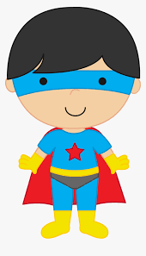  Design your own superhero with superpowers. | 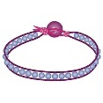  Make a friendship bracelet out of thread, beads or wool. | Design an exercise circuit in your garden or house for your family to complete. | Make musical instruments out of things you find in your house.
Join in with a BBC Supermovers video. | 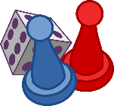  Make your own board game. | Design a new Easter egg and make a poster advertising it. | Make a collage of your favourite things using magazines or drawings. | Do an Oti Mabuse dance class on YouTube* | Walk or run a daily mile.
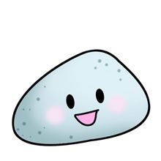  Paint rocks and turn them into rock pets. | Create a poster showing healthy and unhealthy foods. | 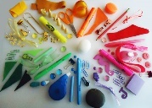  Make a colour wheel out of objects in your house. | 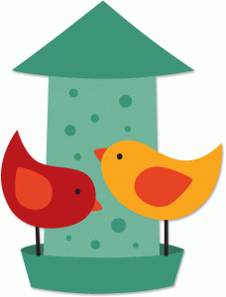  Create a bird house or bird feeder to hang in your garden. | 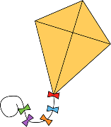  Make your own kite. | Do a Joe Wicks workout on YouTube*
*Have a parent’s permission and guidance when using Youtube.

