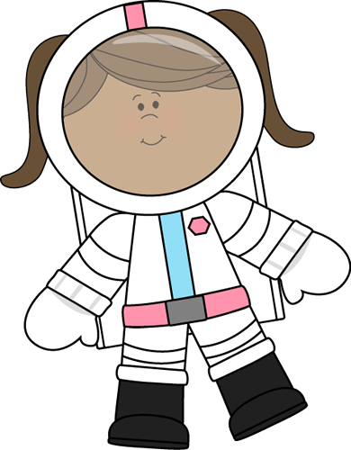
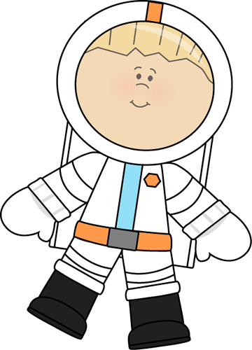
- Astronaut selection

- I can say the numbers in order to 10

- I can recognise the numerals 1 to 5
- I can count up to three or four objects by saying one number name for each of them
- I can count out up to six objects from a larger group
- I can select the correct number to represent 1 to 5
- I can select the correct number to represent 1 to 10
- I can count objects to 10
- I can count beyond 10

