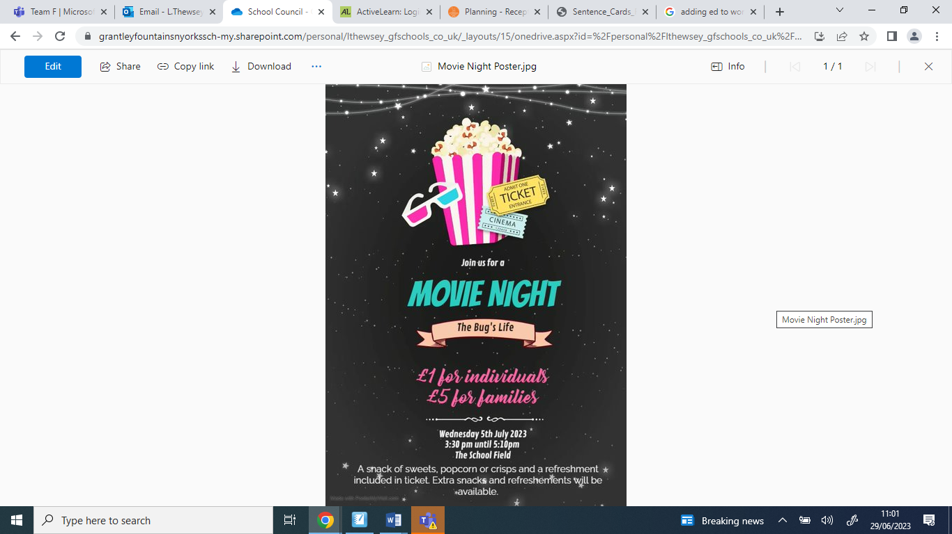

Thursday 13th July

3:30 pm until 5pm

The School Field