Chinese New Year

Phase 2 High Frequency Words Activity Booklet

Name:

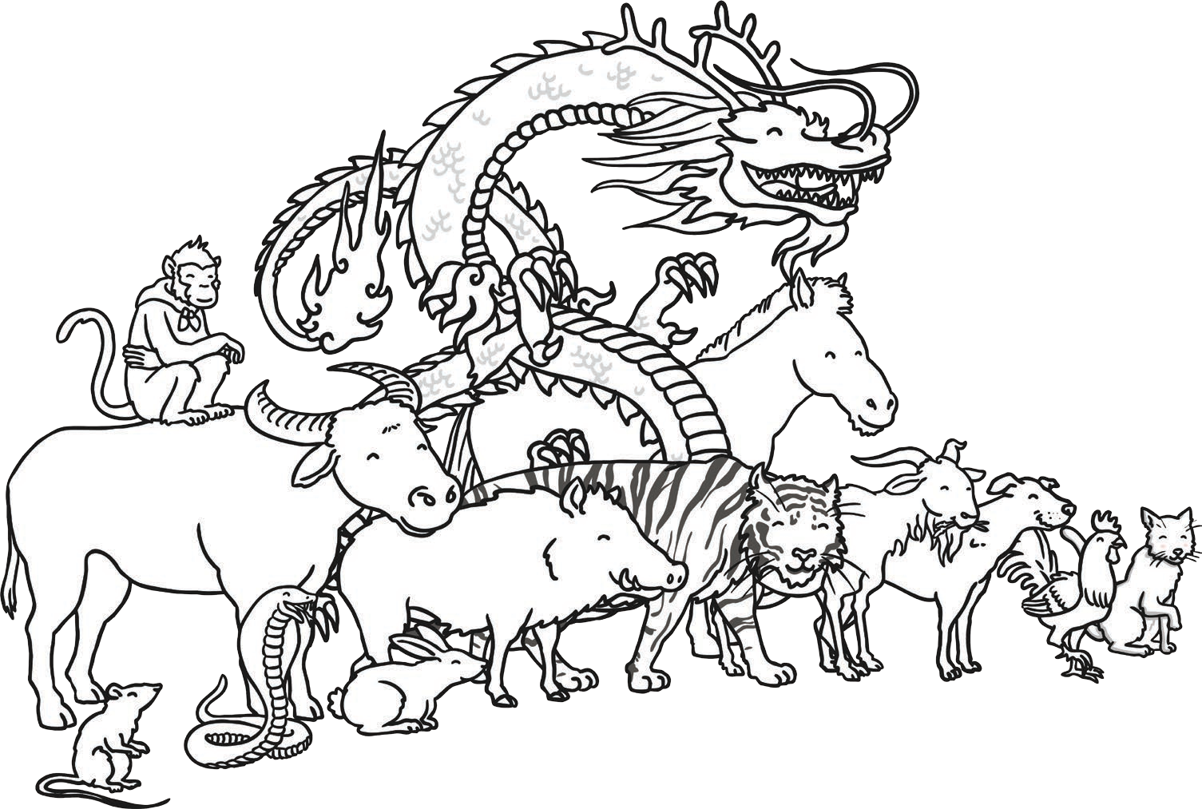

# Chinese Lantern High Frequency Word Colouring

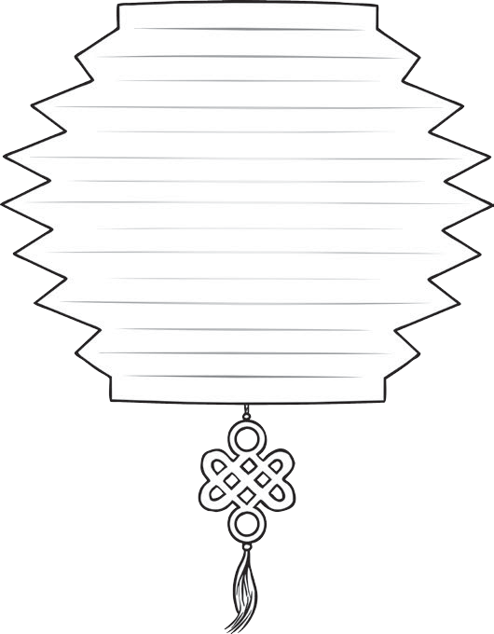

**it**

**to**

**in**



**at**

Read the high frequency words and colour the Chinese lanterns in using the clues



**is**



**i**

i = red to = blue is = yellow at = green it = orange in = purple

# Chinese New Year Money Envelopes High Frequency Word Writing

When it is Chinese New Year, children receive money in red envelopes. Copy the tricky words on to the money envelopes.

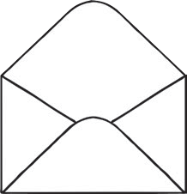



**dad**



**you**



**mum**



**and**



**the**



**she**

# Chinese New Year Find and Read

Use a magnifying glass to find the animals hidden around the picture. What high frequency words are on the animals? There are 8 to find.

**in**

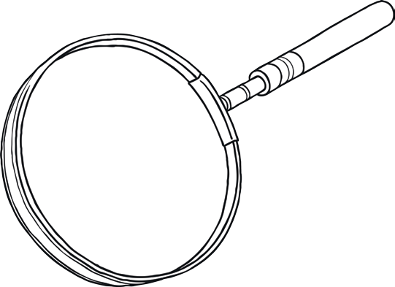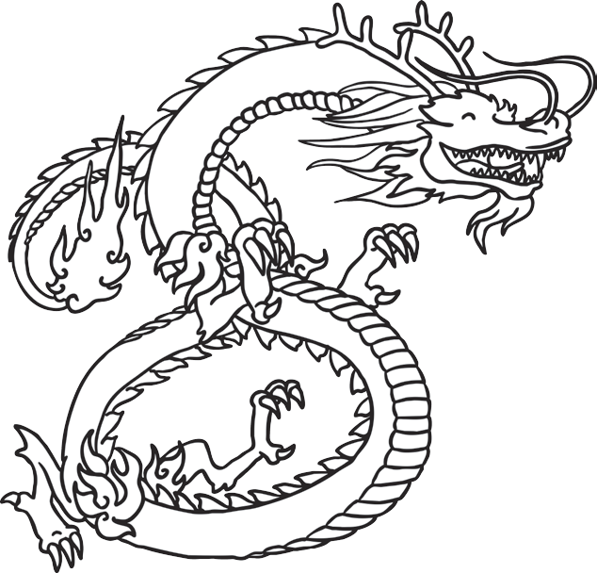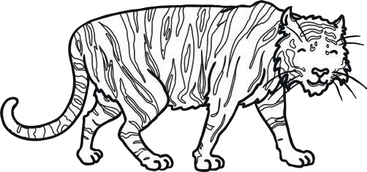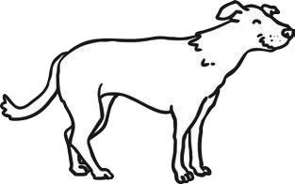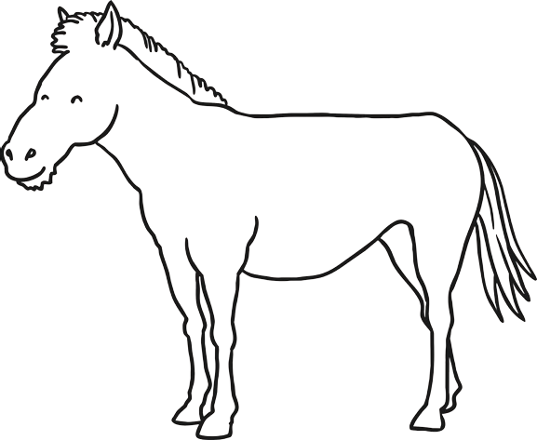

he

**it no**

the

**can**



**you**



**i**

# Chinese Kites Reading High Frequency Words

Read the high frequency words and then colour the kites.

# go

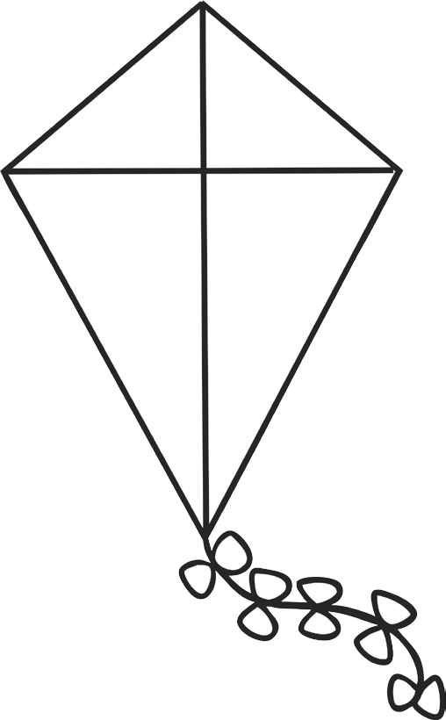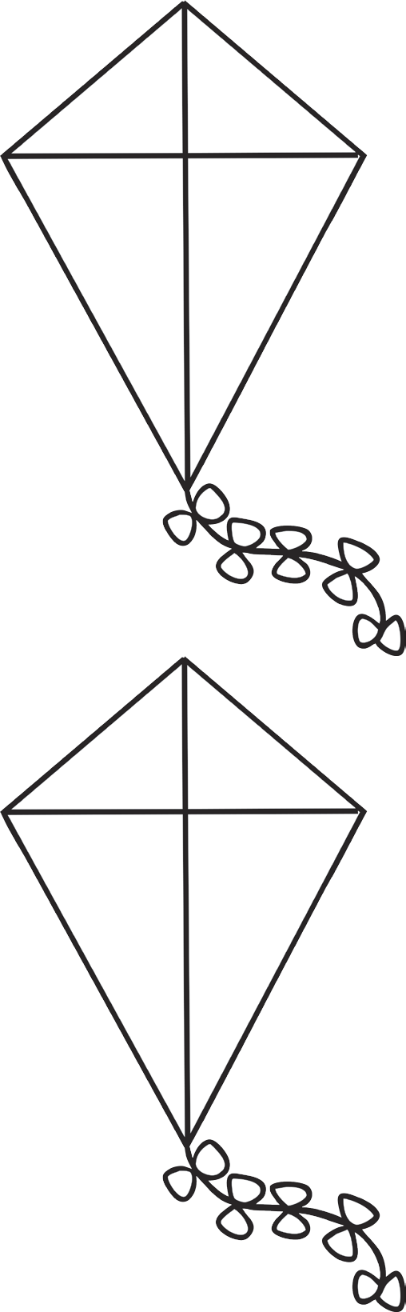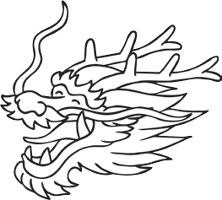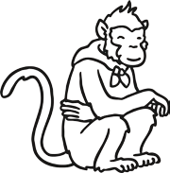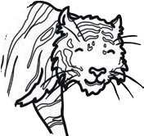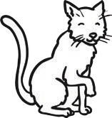

**said**

**she**

**my**

**and**

**mum**

# Chinese New Year Animals Matching High Frequency Words

Draw lines to join the animals together from the Chinese New Year story to show the matching high frequency words.

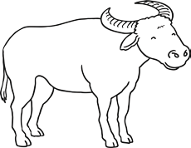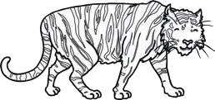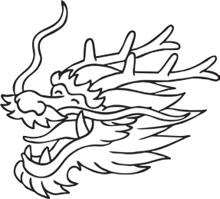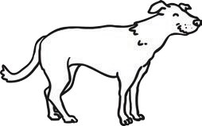

**can**

**my**

**no**

**is**

go

**he**

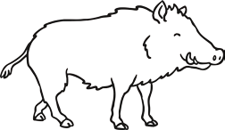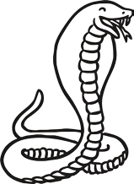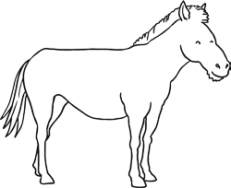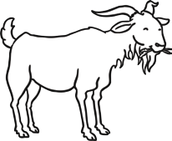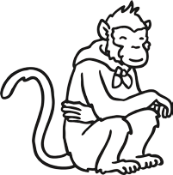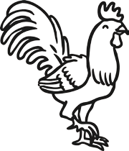

**go**

**no**

is

**my**

**he**

**can**