

**Suitcase**

**If you travel on an aeroplane to another country, your suitcase has to be a certain size and a certain weight so they can fit it on. The length of the suitcase is usually measured in centimetres and the weight is usually measured in kilograms.**

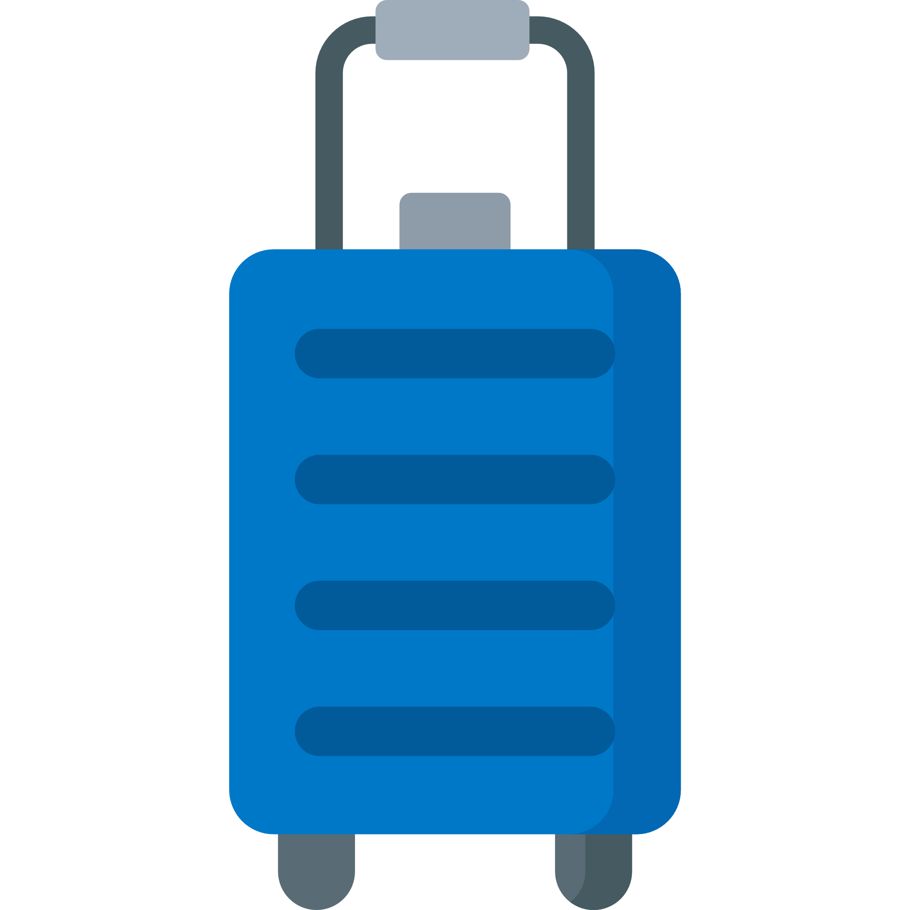

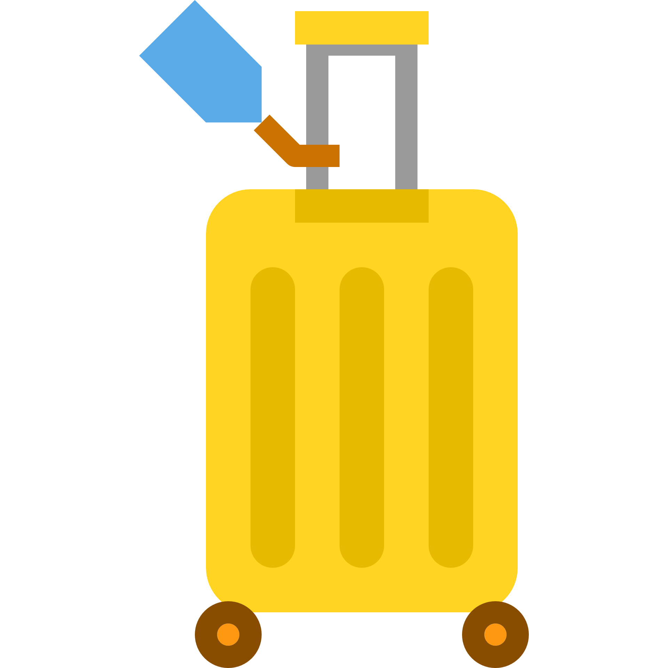

90cm

25cm

45cm

75cm

43cm

56cm

Checked-in suitcase size

Carry-on suitcase size

Weight – 32kg

Weight – 23kg



Look at the suitcase sizes below.

* What is the length of the checked-in suitcase?
* Can you find something in your home or classroom that is the same length as the carry-on suitcase?
* How much bigger is the width of the checked-in suitcase than the carry-on suitcase?
* Which suitcase is the heaviest?
* How much do you weigh? Is it more or less than each suitcase?
* Measure a suitcase or bag. Would you be able to take it on an aeroplane?