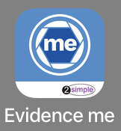
Download the Evidence Me Parent App
The Evidence Me Parent App can be downloaded by clicking the above icon.PLEASE NOTE: The Evidence Me app is currently only available for Apple devices

Manually Download the App
  - Visit the App store on your device and search for Evidence Me by 2Simple
  - Follow the steps to download the app
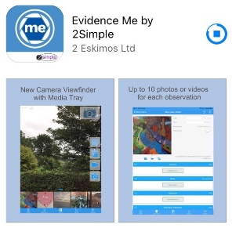

Log in to the app
  - Open the app on your device
  - Enter your Email and password
  - Tap Login
  - The following pop up message will appear:
    - “Evidence me” Would Like to Access the Camera – Tap OK
    - “Evidence me” Would Like to Access the Microphone – Tap OK
    - Would you like to save this password to use with apps and websites? Please Note: If you are using a shared iCloud account we would recommend clicking Not Now
    - Do you want to set a PIN? we recommend that you select OK to keep your app secure (you can select No and set this up at a later date).
  - Press OK

Create a Parent App Observation
For each Parent Share observation, you can add evidence. This could be an activity or a piece of work.
Tap on one of the below icons on the app Create screen to start your observation

Photo

  - The photo will be instantly captured
  - Edit your image using the image edit features – Please Note this feature will only appear if you have switched on Enable Crop Screen in the Settings area of the app
  - Tap Done in the bottom right-hand corner
  - Select Tap to Edit
TOP TIP: Your observation will automatically appear on your recent observations bar so you can always edit it at a later date.

Video

  - The video will automatically start recording
  - Click on the stop button to stop the recording
  - Click Tap to Edit
TOP TIP: Your observation will automatically appear on your recent observations bar so you can always edit it at a later date.

Existing photo/ video

  - Your device gallery will instantly open
  - Select the image(s) you would like to upload (max 10)
  - Click Select in the top right-hand corner

Continue without evidence

  - A blank observation will automatically open

Add Observation Details

  - Tap to edit an observation
  - Tap Add Learners + – Please note a learner must be added in order for the observation to be sent to the school or setting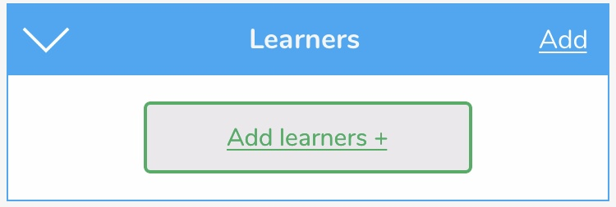
  - Tap Add Parent Notes +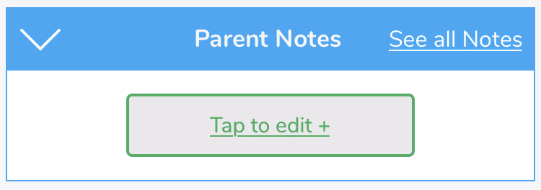
Observations will automatically be uploaded to the school’s account as long as your device is connected to wifi. This is indicated by a green dot appearing in the top left-hand corner of the observation thumbnail.

View School Observations
You will receive an email notification every time an observation is uploaded to the app for your child. By clicking on the link within the email notification you will automatically be taken to the new observation within your Evidence Me App.
Add Parent Notes to any observations by tapping Tap to edit + under the Parent Notes area of the observation. Type your note and click Back in the top left-hand corner for your notes to be automatically saved to the observation.
If you have any further questions please contact your child’s school/ setting directly.

